**BDA Lab 10**

1. Connect your database to python using pyMongo
2. Get rid of all the NaN values in host_acceptance_rate
3. Change all the host_acceptance_rate values from str ‘33%’ to int 33 and so on.
4. Now find all the records where host_acceptance_rate is between 90 and 100 percent and show only the host_acceptance_rate as shown in the requirement image below:

**Requirements:**

**1-**

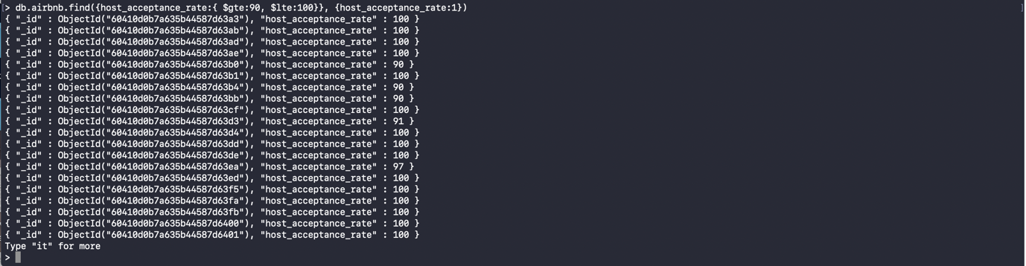

**2- Paste your processing code here**

**3- Save this file as .pdf with your name_rollNo.pdf and submit**